BDSH Foremost Report – EIGHT.dd
Contents
Report 1
Files 1
JPG 1
GIF 5
OLE 6
ZIP 9
PNG 11
PDF 14
Time Taken – 4 hours 15

Report
This report is an analysis of the EIGHT.dd file, after use of Foremost to carve the files from it. Throughout the investigation the following types and amounts of files were found:
jpg:= 12
gif:= 4
ole:= 5
zip:= 4
png:= 18
pdf:= 1
44 total files.

Files

JPG

00000552.jpg
Appears to be a low-quality photo of a cruise ship on the water.
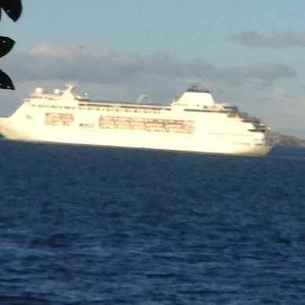

00001840.jpg
Appears to be photo of a cat lying stretched out between two rafters of a ceiling.
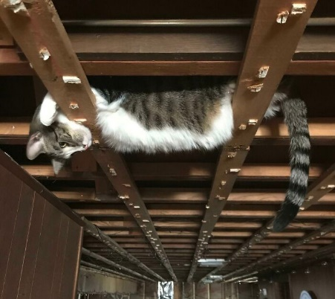

0000224.jpg
Appears to be a photo of a burned out power board.
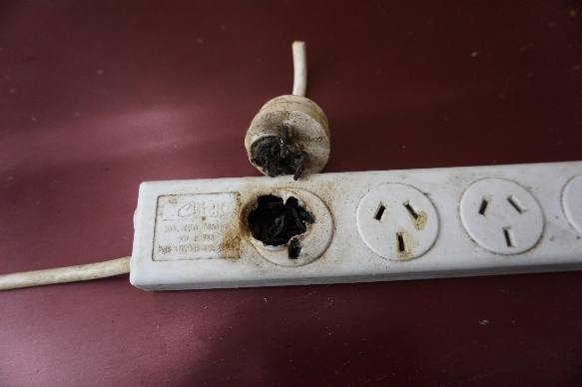

00004289.jpg
Appears to be a photo of an old black and white photograph of a school class, or possibly sports team.
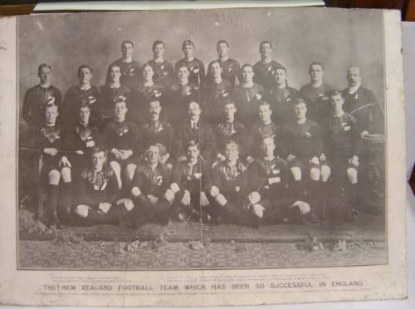

00004372.jpg
Appears to be a low quality photo of a woman wearing a yellow bikini.


00004383.jpg
Appears to be the same image as 00004372.jpg, but with a pink square of corruption on it.


00004511.jpg
Appears to be a photo of the Sydney Opera house, but with a red lining and insignia decorations.
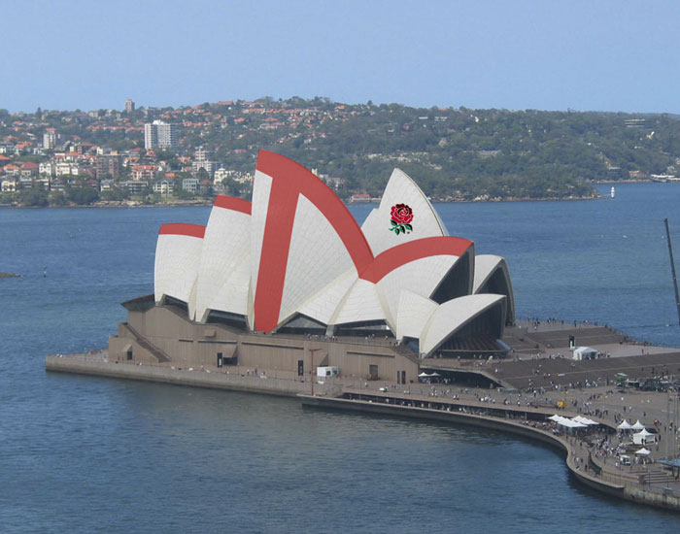

00004659.jpg
Appears to be a photo of a man at the pool wearing black swimming trunks.


00004712.jpg
Appears to be a photo of two men at the pool, wearing swimming togs.


00004787.jpg
Appears to be a low quality photo of a group of people wearing swimming outfits.


00004864.jpg
Appears to be a photo of a street intersection taken from an outside café table.
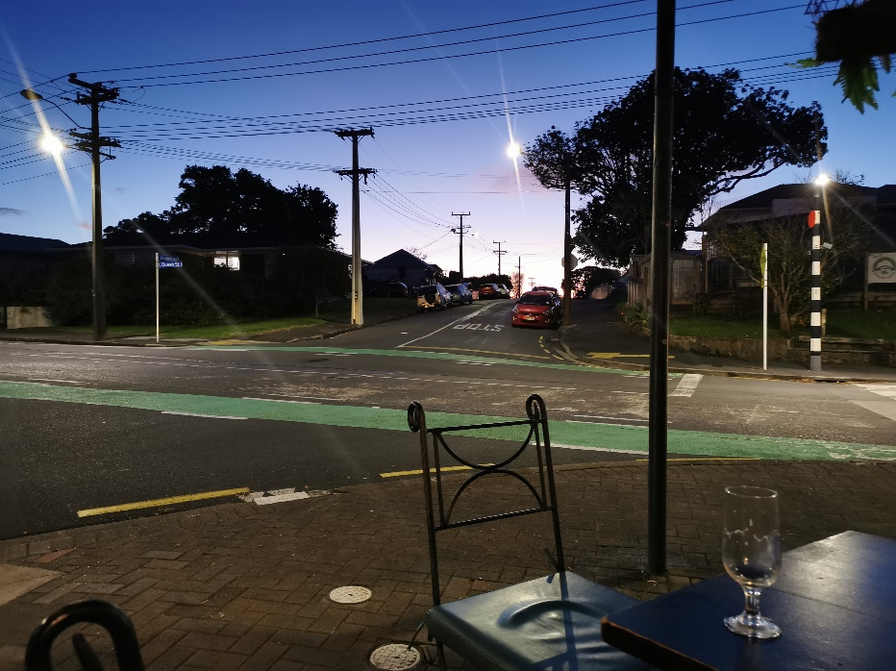

00010512.jpg
Appears to be a photo of an electronic thermometer displaying 990 degrees, however other text on the screen indicates that it is likely 066 degrees and is being held upside down.
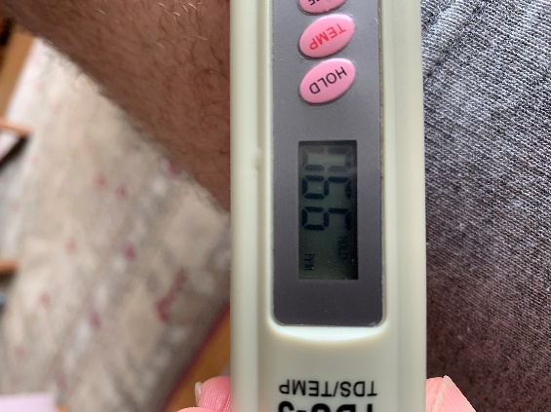

GIF

00038731.gif
Appears to be an image of a woman holding her hand up to the sky, backlit by a sunset.


00038735.gif
Appears to be the same as 00038731.gif

00038807.gif
Appears to be a series of red, white, and blue lines, possibly a section of a website banner or a game asset.


00038808.gif
Appears to be the same image as 00038807.gif.

OLE

000042000.ole
Contains the text “Hidden 1 Where is the hidden message in this document?” Below, the words “OK you found me” is repeated 15 times in white text, hidden against the white background.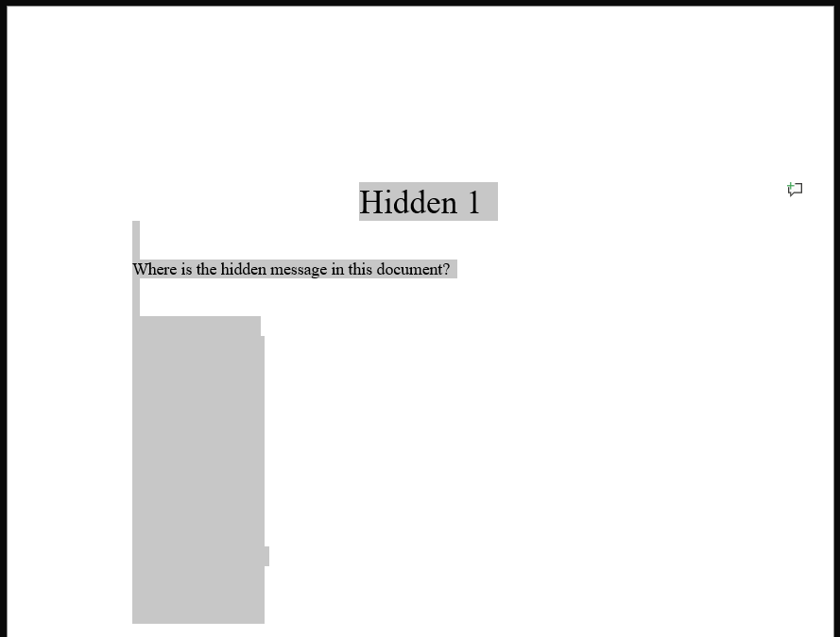

00004240.ole
Contains the text “Hidden 2 Where is the hidden message in this document?” Below, the words “OK you found me” is repeated 15 times, hidden behind a white image. 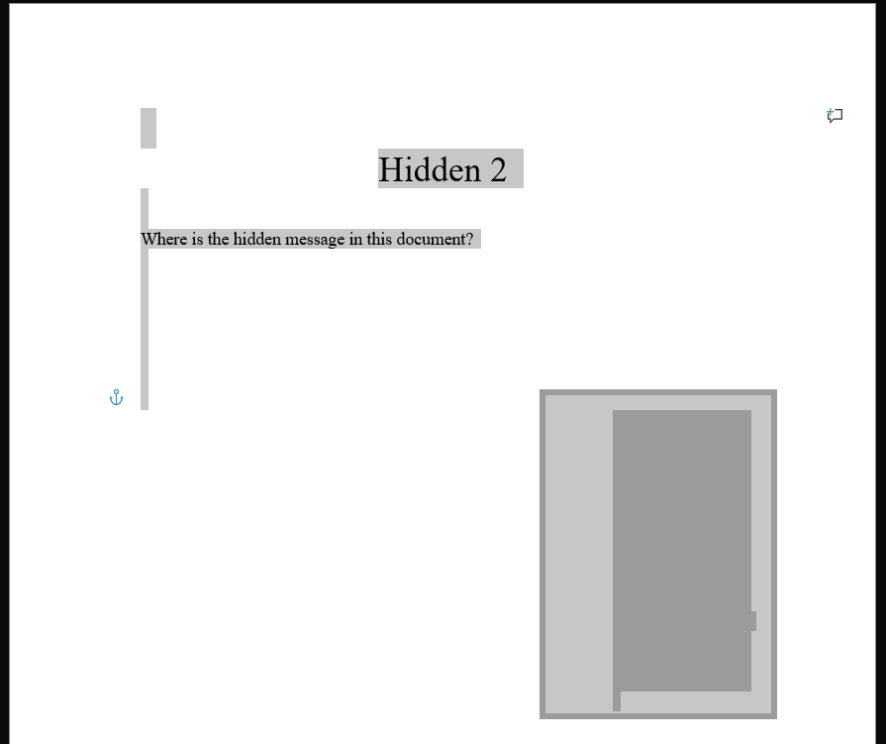

00004280.ole
Contains the text “Hidden 3 Where is the hidden message in this document”.
The image 00004289.jpg is present, shrunken down to the point where it appears to be the full stop at the end of the sentence.
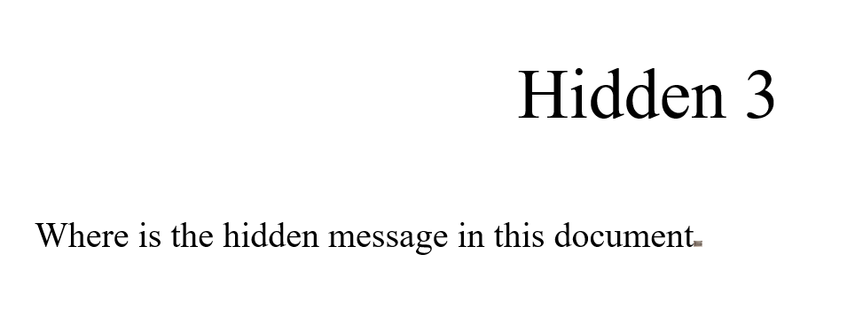

00004368.ole
Spreadsheet containing a person’s exam results. Scrolling down to line 2650 reveals a higher quality version of 00004372.jpg.
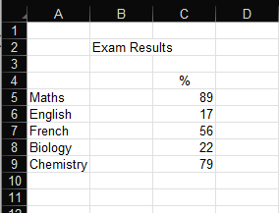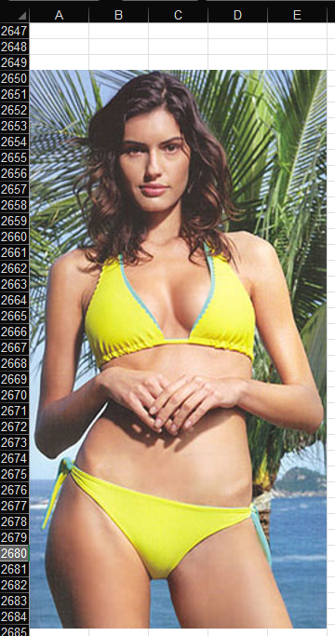

00004504.ole
Contains the text “Hidden 5 Hey this is a great picture of what the Aussies had to do to the Sydney Opera House when they lost to the English.” Below is 00004511.jpg. Hidden behind the image are images 00004659.jpg, 00004712.jpg, 00004787.jpg, and 00004806.png
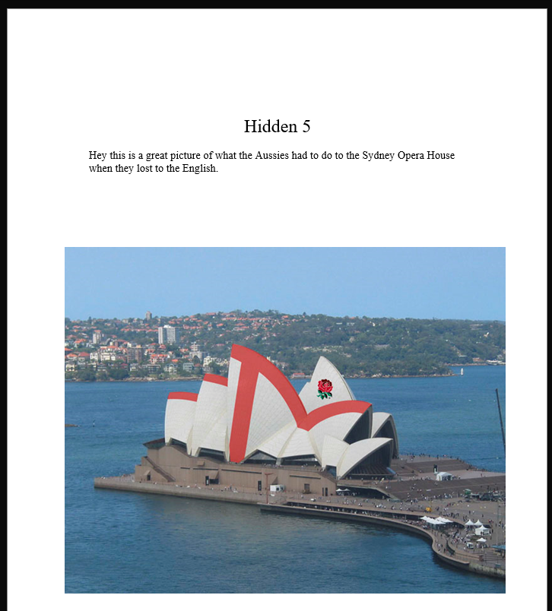
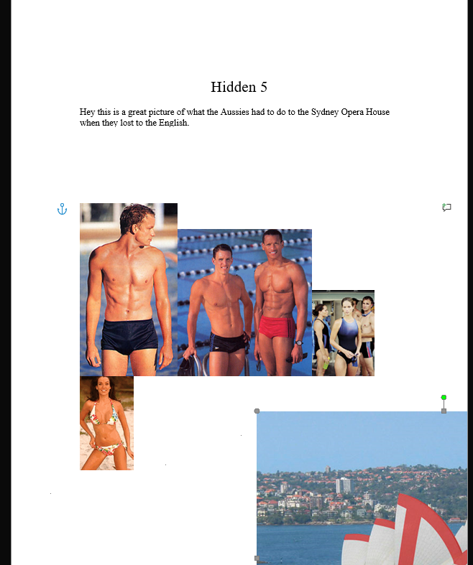

ZIP

00038535.zip
Contains image files that appear to be from a webpage.
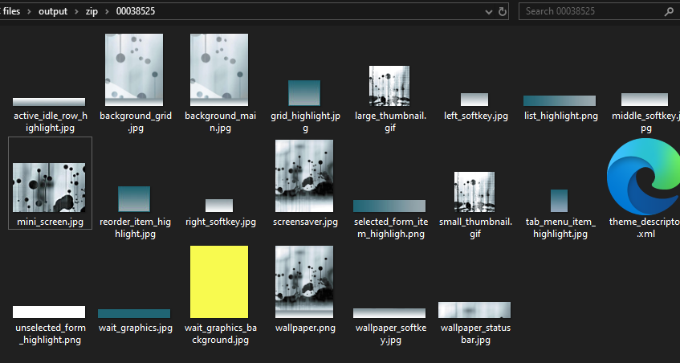

00038661.zip
Contains images that appear to be from a webpage, appearing as variations of 00038731.gif and 00038735.gif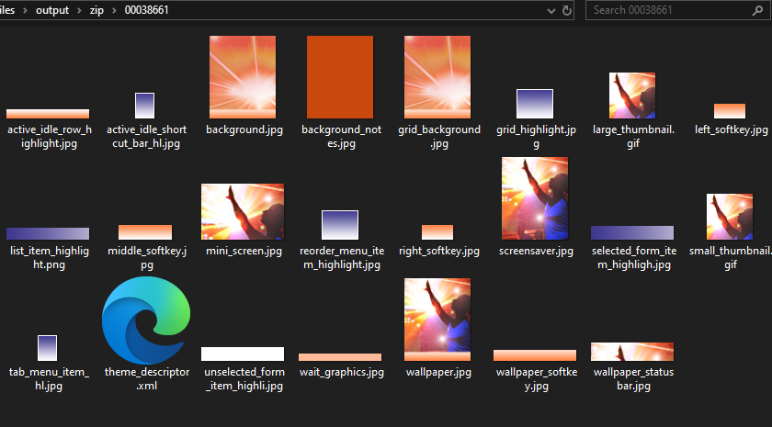

00038749.zip
Contains images that appear to be from a webpage, appearing to be variations of 00038807.gif and 00038808.gif
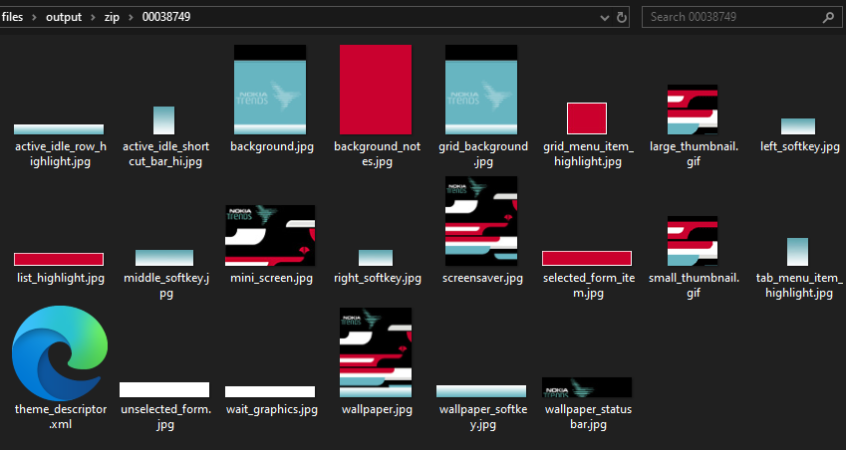

PNG

00004806.png
Appears to be a photo of a woman on a beach wearing a white bikini


00016172.png
Appears to be an image of a red dice.


00016235.png
Appears to be an image of Leonardo DaVinci’s Vitruvian Man but on a blue wireframe, likely a game asset.
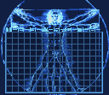

00016275.png
Appears to be an image with the words “nivel, record, puntos, tiempo” in orange text with white and orange numbers appearing alongside. Likely a screenshot from a game.
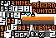

00016290.png
Appears to be a series of sprites. Likely a game asset.


00016309.png
Appears to be an image of the word “gameloft” in orange text.

00016241.png
Appears to be an image of a blue white and red background with a red grid overlaying the bottom three-quarters of the image. Likely a screenshot from a game.
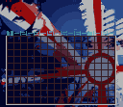

00016281.png
Appears to be pixel art of game assets.
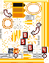

00016291.png
Appears to be an image of the words “Shinin’, urbanization, mystic [unintelligible], sandstorm calling”, and some of the sprites from 00016290.png in a column with “VS” next to each of them, likely facing off in a game.
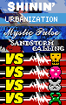

00016312.png
Appears to be an image of the words “gameloft jukebox”.


00016174.png
Appears to be an image of the words “paueba 4 adictivas demos de juegos”, which translates to “Paueba 4 addictive game demos”


00016271.png
Appears to be approximately 300 red, white, and green squares laid out in a tile pattern, likely a screenshot from a game.
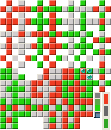

00016283.png
Appears to be assets for a game.


00016298.png
Appears to be a part of a text font asset for a game.

00016224.png
Appears to be an image of a pixelated highway overpass with a city in the background. A grid overlay similar to the one in 00016241.png covers the bottom three-quarters of the image. Likely a screenshot from a game.
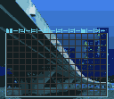

00016273.png
Appears to be assets for a game.


00016286.png
Appears to be the cover of the game Lumines.


00016299.png
Appears to be more game assets, containing the words “Ganaste! Perdiste! Supernado, Retrantes, Nivel, Objective, Bloques”, which translates to "You won! You lost! Super swim, Portraits, Level, Objective, Blocks".
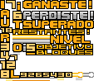

PDF

00002080.pdf
This pdf was encrypted, and could not be accessed without inputting a password.

Time Taken – 4 hours

